Call for applications for the European Training Programme
EKRAN+ 2022 is open!
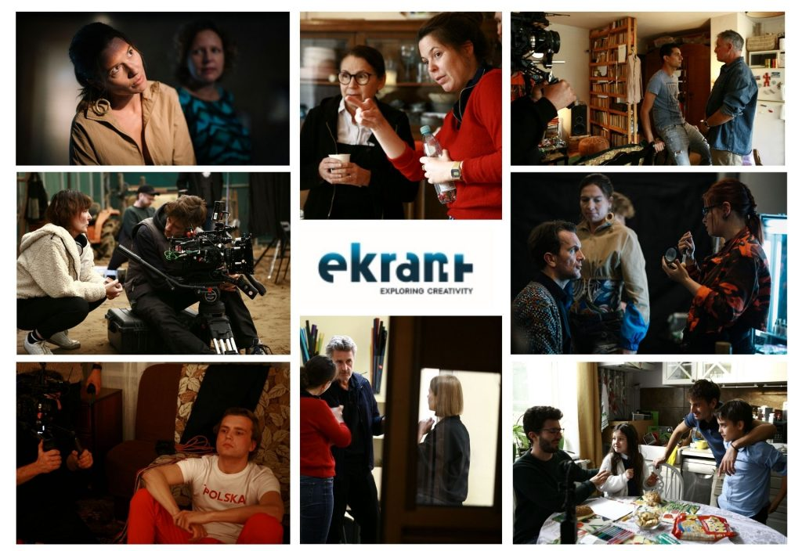
Submissions for EKRAN+ the international training programme for directors/scriptwriters-directors are open!
- This time the programme will focus on creative development of the first and second feature film projects from EKRAN+ Partners’ countries: Austria, Croatia, Lithuania, Switzerland and Poland.
- Throughout the programme, you will develop your script/treatment and shoot one scene from your script with the focus on identifying and refining the right tone and visual language for your future film.
The deadline for applications is February 28, 2022. Participation in the programme is free of charge.
What is EKRAN+?
EKRAN+ is a professional training programme aimed at developing scripts/treatments and producing scenes from each project under the guidance of renowned international filmmakers, including Wojciech Marczewski (Director of the EKRAN+ Programme), Paweł Pawlikowski, Ildikó Enyedi, Udayan Prasad, Denijal Hasanović Marilyn Milgrom, Margaret Glover, Volker Schlöndorff, Roshanak Behesht Nedjad.
Each participating project is represented by a Creative Team consisting of a director (or scriptwriter-director), scriptwriter (or co-writer), director of photography and producer.

The EKRAN+ programme includes:
- treatment and/or script development, through group and individual work;
- preparation for shooting: casting, storyboard and individual consultations with the tutors;
- shooting;
- editing;
- evaluation with group and tutor analysis of the produced scenes.
The Creative Team is offered a choice of locations, actors and set designs, within the usual logistical and budgetary constraints.

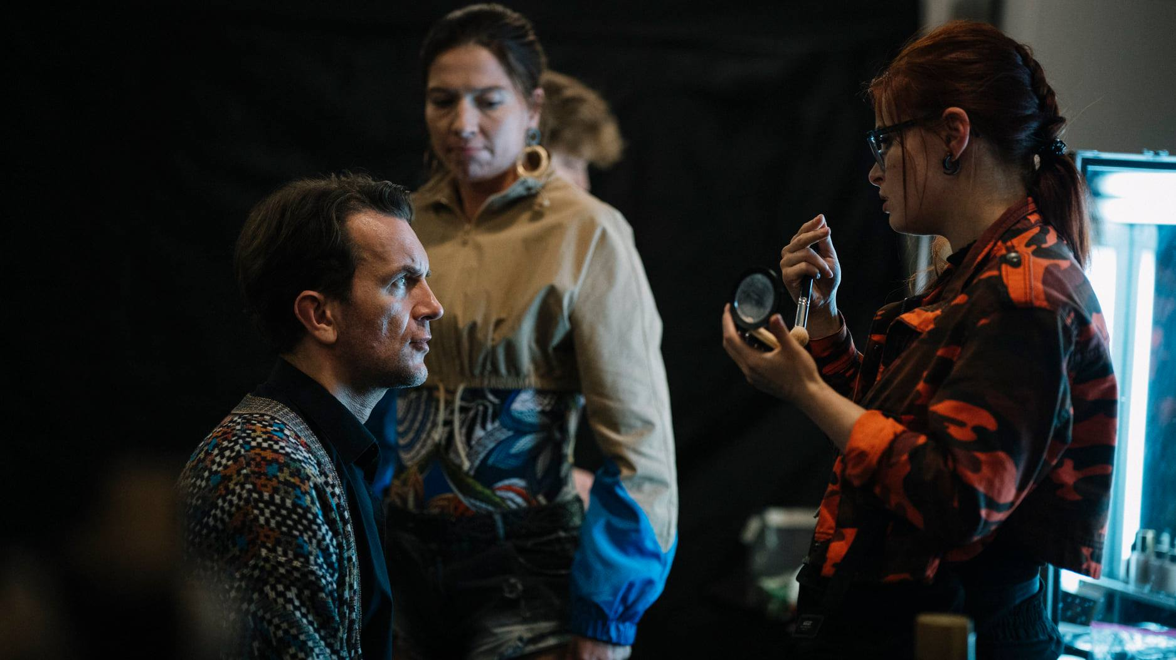
Tomasz Kot during the filming of the “Taming of the shrew” workshop scene by Katarzyna Szyngiera-Krajewska. Photo by Karolina Grabowska
What can you achieve by participating in the programme?
Each Creative Team finishes the EKRAN+ course with a well-developed treatment or first draft of the script and a scene demonstrating the tone, genre and visual language of the project. You can use the completed scene as a demo/pilot, a visual material to accompany the script, which can be helpful in finding partners and funding sources for the film. By working on scene in practice you will find out what style works best for your story, and you can treat participation in the programme as a creative test or “visual laboratory” before starting the actual work on your film.
Is EKRAN+ for you and how much does it cost?
EKRAN+ is based on teamwork and involves professionals from different film disciplines. The main participants are European directors or scriptwriters-directors who have already made a feature film or several shorts. In order to be accepted by EKRAN+, the creative team should be consisting of: director/writer-director, writer or co-writer, producer involved in the project, and the director of photography.
Participation in the programme is completely free of charge. The selected directors and their teams will be granted scholarships including participation fees and accommodation. Travel costs are to be covered by participants.

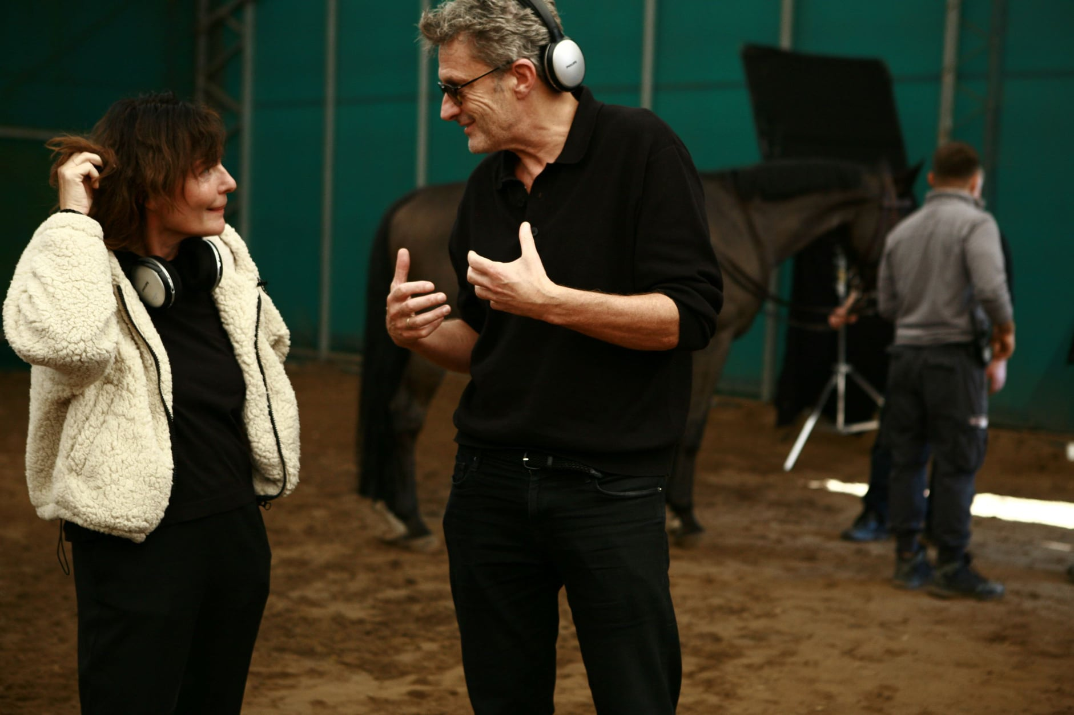
Evi Romen and EKRAN+ tutor Paweł Pawlikowski during the workshop scene from the project “Happyland”. Photo by Agnieszka Patela

Schedule of sessions
The programme is divided into two online sessions and one on-site session, which are scheduled on the following dates:
- session 1: April 25 – 28, 2022 (online),
- session 2: June 21 – 29, 2022 (on-site, Warsaw, Poland),
- session 3: September 5 – 6, 2022 (online).

The schedule of EKRAN+ 2022 will be continuously adjusted to the situation related to the COVID-19 pandemic. Detailed description of each session can be found on the EKRAN+ programme website.
Deadline: February 28, 2022
To apply, please fill out the registration form available at EKRAN+ website. We are waiting for applications until February 28, 2022.
Watch EKRAN+ 2021 making of.

-----------------------------------------
Contact:
Agnieszka Marczewska, Ekran+ programme manager: amarczewska@wajdaschool.pl

Follow us!
website: https://ekranplus.eu
Facebook: https://www.facebook.com/EKRANprogramme/
Instagram: https://www.instagram.com/ekran.plus/

Partners
EKRAN+ is a joint project of Wajda Studio and Wajda School (Poland), Focal (Switzerland), Austrian Film Institute, Croatian Audiovisual Centre, Lithuanian Film Centre, with the support of the Polish Film Institute and Polish Filmmakers Association.
Technology partners: Heliograf and Koi Studio.

